FINAL YEAR PROJECT REPORT
SIEM & SOC
Attack Detection, Prevention and Logging
Implementation using Wazuh, Kali Linux, Windows 10 and Oracle VirtualBox
━━━━━━━━━━━━━━━━━━━━━━━━━━━━━━━━━━
Submitted by
Muhammad Raheel Khan
Muhammad Talha Khan
Abdullah Sohail
Semester: 3rd
Academic Session: 2026
Controlled Cybersecurity Laboratory
All tests in this report were performed only on privately owned virtual machines.

Declaration
This report documents a controlled academic experiment conducted in an isolated Oracle VirtualBox environment. The attack simulations were directed only at the project team's own Windows virtual machine. No public, third-party, or production systems were targeted. Administrative passwords and other sensitive credentials have been intentionally omitted or redacted from this report.

Abstract
This project implements a small Security Operations Center (SOC) laboratory to evaluate the difference between security event detection and automatic prevention. Three virtual machines were deployed: Kali Linux as the attacker, Windows 10 as the monitored victim, and Ubuntu as the Wazuh server. The first test used repeated failed SMB authentication attempts from Kali Linux to the Windows endpoint. The traffic reached the Windows SMB service, Windows generated failed-logon events, and Wazuh displayed five alerts under rule 60122. This proved that the default configuration detected the activity but did not block the source. Wazuh Active Response was then enabled through the Wazuh dashboard by linking rule 60122 to the built-in Windows netsh response for 300 seconds. When the same attack was repeated, the connection changed from NT_STATUS_LOGON_FAILURE to NT_STATUS_IO_TIMEOUT and TCP port 445 appeared filtered from Kali Linux. The experiment therefore demonstrated the full cycle required by the project proposal: attack simulation, detection-gap identification, configuration tuning, re-testing, and verified prevention.
Keywords: SIEM, SOC, Wazuh, Active Response, SMB, Windows Event ID 4625, Rule 60122, Kali Linux, VirtualBox, incident response.

Document conventions
- Commands are shown exactly as entered in Ubuntu, Kali Linux, Windows PowerShell, or Windows Command Prompt.
- Values in angle brackets such as <ADMIN_PASSWORD> are placeholders and must be replaced with the locally generated value.
- “Attack successful” in the baseline phase means that the authentication requests reached the victim and generated security events. It does not mean that the attacker obtained access.

Table of Contents
1. Introduction
2. Laboratory Design and Architecture
3. Virtual Machine Installation and Configuration
4. Network Configuration and Connectivity Testing
5. Wazuh Server Installation on Ubuntu
6. Windows Wazuh Agent Deployment
7. Preparing the Windows Victim for the SMB Test
8. Baseline Attack: Detection Without Prevention
9. Enabling Wazuh Active Response through the Dashboard
10. Re-running the Attack and Validating Prevention
11. Results and Discussion
12. Troubleshooting and Lessons Learned
13. Security, Ethics and Limitations
14. Conclusion and Future Work
References
Appendix A: Complete Command Checklist
Appendix B: Live Demonstration Script

List of Figures
Figure 1. Laboratory architecture and data flow.
Figure 2. Wazuh installation completed successfully (password redacted).
Figure 3. Ubuntu Wazuh services and host-only IP verification.
Figure 4. Windows Wazuh agent service and IP configuration.
Figure 5. Active Windows endpoint visible in the Wazuh dashboard.
Figure 6. Kali Linux confirms TCP/445 is open before the attack.
Figure 7. Five controlled SMB authentication failures generated from Kali.
Figure 8. Wazuh detects five events under rule 60122.
Figure 9. Active Response XML added through the Wazuh dashboard.
Figure 10. Same attack times out and TCP/445 becomes filtered.
Figure 11. Before-and-after detection/prevention process.

1. Introduction
Security Information and Event Management (SIEM) platforms collect and analyze security telemetry, but detection alone does not always stop an attack. The project proposal identified this gap and required a controlled attack to be executed, observed, tuned, and re-run so that the improvement could be measured. Wazuh was selected because it provides an open-source SIEM/XDR platform composed of a Wazuh agent and three central components: the Wazuh server, indexer, and dashboard [1].

1.1 Problem Statement
A default SIEM deployment can report malicious or suspicious activity while allowing the activity to continue. In this project, repeated failed authentication attempts were expected to be visible in Wazuh but not automatically blocked until an Active Response policy was configured. The practical question was therefore: can the same attack be detected first and then automatically prevented after changing Wazuh configuration?

1.2 Project Objectives
- Build an isolated three-VM cyber range using Oracle VirtualBox.
- Install the Wazuh central components on an Ubuntu VM.
- Install and enroll a Wazuh agent on a Windows 10 victim VM.
- Perform a controlled failed-authentication attack from Kali Linux.
- Confirm that Windows and Wazuh record the attack.
- Identify the detection-only gap in the default configuration.
- Enable Wazuh Active Response through the Wazuh dashboard.
- Re-run the same attack and prove that it is blocked.
- Present a clear before-and-after comparison supported by commands and screenshots.

1.3 Scope
The experiment is intentionally narrow and repeatable. It uses SMB authentication on TCP port 445 and a non-existent username (badguy). The attack does not exploit a vulnerability, execute malware, or obtain a valid session. It generates failed network logons that Windows records as Event ID 4625, which Microsoft defines as a failed logon event generated on the computer where the attempt was made [6].

1.4 Expected Outcome
Before tuning, Kali should reach the Windows SMB service and receive NT_STATUS_LOGON_FAILURE while Wazuh displays rule 60122 alerts. After tuning, Wazuh should execute its Windows netsh Active Response, causing later attempts to time out and the SMB port to appear filtered.

2. Laboratory Design and Architecture
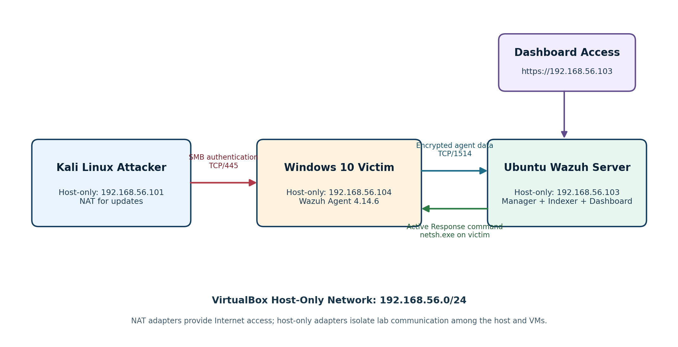
Figure 1. Laboratory architecture and data flow.
Source: Created for this report from the implemented lab topology.

2.1 Host Computer
Component | Implemented value
Host operating system | Windows 10
Processor | Intel Core i5-6500 @ 3.20 GHz
Memory | 16 GB RAM
Virtualization platform | Oracle VirtualBox
VM storage | Ubuntu/Wazuh VM moved to D: drive after host disk-space exhaustion

2.2 Virtual Machines and Roles
VM | Role | Host-only IP | Important software
Ubuntu Desktop | Wazuh server | 192.168.56.103 | Wazuh manager, indexer, dashboard, Filebeat
Windows 10 Home | Victim endpoint | 192.168.56.104 | Wazuh agent 4.14.6, SMB service
Kali Linux | Attacker / test generator | 192.168.56.101 | Nmap and smbclient

2.3 Network Design
Each VM used two virtual network adapters. Adapter 1 used NAT for package downloads and Internet access. Adapter 2 used the VirtualBox Host-Only network (192.168.56.0/24) for isolated communication among the host and the VMs. Oracle explains that host-only networking allows communication among the host and VMs without requiring a physical external interface, while NAT gives a guest outbound network access [7].
Adapter | Mode | Purpose
Adapter 1 | NAT | Internet access for operating-system updates and package installation
Adapter 2 | Host-Only Adapter | Private lab traffic among Kali, Windows, Ubuntu, and the host browser

3. Virtual Machine Installation and Configuration

3.1 Install Oracle VirtualBox
- Download and install Oracle VirtualBox on the Windows host.
- Keep the VirtualBox application on the host system drive; VM folders can be stored on another drive.
- Open Tools > Network and confirm that a Host-Only network exists. The default range used in this lab was 192.168.56.0/24.

3.2 Create the Ubuntu Wazuh Server VM
- Create a Linux/Ubuntu 64-bit VM and attach the Ubuntu ISO.
- Install Ubuntu Desktop normally.
- Allocate approximately 3 virtual CPUs and 6 GB RAM for the time-limited lab. The VM displayed about 5.3 GiB usable memory.
- Create an 80 GB dynamically allocated virtual disk.
- Enable Adapter 1 as NAT and Adapter 2 as Host-Only Adapter.
Production recommendation: The Wazuh quickstart recommends 4 vCPU, 8 GiB RAM and 50 GB storage for 1–25 agents [1]. This lab ran with lower CPU/RAM because of host limitations and should not be treated as a production sizing model.

3.3 Create the Windows Victim VM
- Create a Windows 10 VM and complete the operating-system installation.
- Assign at least 1 virtual CPU, 2 GB RAM, and adequate disk space for the operating system and Wazuh agent.
- Enable Adapter 1 as NAT and Adapter 2 as Host-Only Adapter.
- Keep the Windows VM isolated from public exposure; only the lab host-only network was used for attack traffic.

3.4 Create the Kali Attacker VM
- Create or import a Kali Linux VM.
- Enable Adapter 1 as NAT and Adapter 2 as Host-Only Adapter.
- Install Nmap and smbclient if they are not already present.
Kali package preparation
sudo apt update
sudo apt install -y nmap smbclient

4. Network Configuration and Connectivity Testing

4.1 Identify Ubuntu Addresses
Ubuntu commands
hostname -I
ip -br address

The Ubuntu output contained 10.0.2.15 for NAT and 192.168.56.103 for the host-only network. The host-only address was selected as the permanent Wazuh server address used by the Windows agent and dashboard.

4.2 Identify Windows Addresses
Windows PowerShell or Command Prompt
ipconfig

The Windows output contained 192.168.56.104 on the host-only adapter and 10.0.3.15 on the NAT adapter. The host-only address was used as the victim target.

4.3 Identify Kali Addresses
Kali command
ip -br address

The Kali host-only address was 192.168.56.101. This address later became the source IP blocked by Wazuh Active Response.

4.4 Connectivity Tests
From Kali to Windows
ping -c 3 192.168.56.104

From Windows to Ubuntu
ping 192.168.56.103

From Windows to the Wazuh manager ports
Test-NetConnection 192.168.56.103 -Port 1514
Test-NetConnection 192.168.56.103 -Port 1515

TCP port 1514 is used for normal agent communication and port 1515 is used for enrollment in the implemented setup. Successful connectivity confirmed that the host-only network was functioning before installing the agent.

5. Wazuh Server Installation on Ubuntu

5.1 Pre-installation Checks
Ubuntu validation commands
cat /etc/os-release
uname -m
nproc
free -h
df -h /
hostname -I
ping -c 3 8.8.8.8
getent hosts packages.wazuh.com

These checks confirmed the operating system, 64-bit architecture, available CPU/RAM, free disk space, IP addresses, Internet access, and DNS resolution.

5.2 Install Required Package
Ubuntu commands
sudo apt update
sudo apt install -y curl

5.3 Download the Wazuh Installation Assistant
Ubuntu commands
curl -sO https://packages.wazuh.com/4.14/wazuh-install.sh
ls -lh wazuh-install.sh

The official quickstart command downloads the Wazuh 4.14 installation assistant and performs an all-in-one installation using the -a option [1].
Official supported-system quickstart command
curl -sO https://packages.wazuh.com/4.14/wazuh-install.sh && sudo bash ./wazuh-install.sh -a

5.4 Clean Previous Partial Components (Only When Required)
Cleanup command used before the successful reinstallation
sudo bash wazuh-install.sh --uninstall

The lab had remnants of an earlier interrupted attempt. The uninstall option was therefore used before the clean installation. A genuinely fresh system does not require this step.

5.5 Command Used in This Lab
Actual final installation command
sudo bash ~/wazuh-install.sh -a -o -i

The -a option installed all central components on one host. The -o option overwrote remaining components from the interrupted installation. The -i option bypassed validation checks because the existing lab used Ubuntu 26.04 and reduced resources. The official supported Ubuntu list in the current quickstart ends at Ubuntu 24.04, so a production deployment should use Ubuntu 24.04 and omit workaround flags [1].
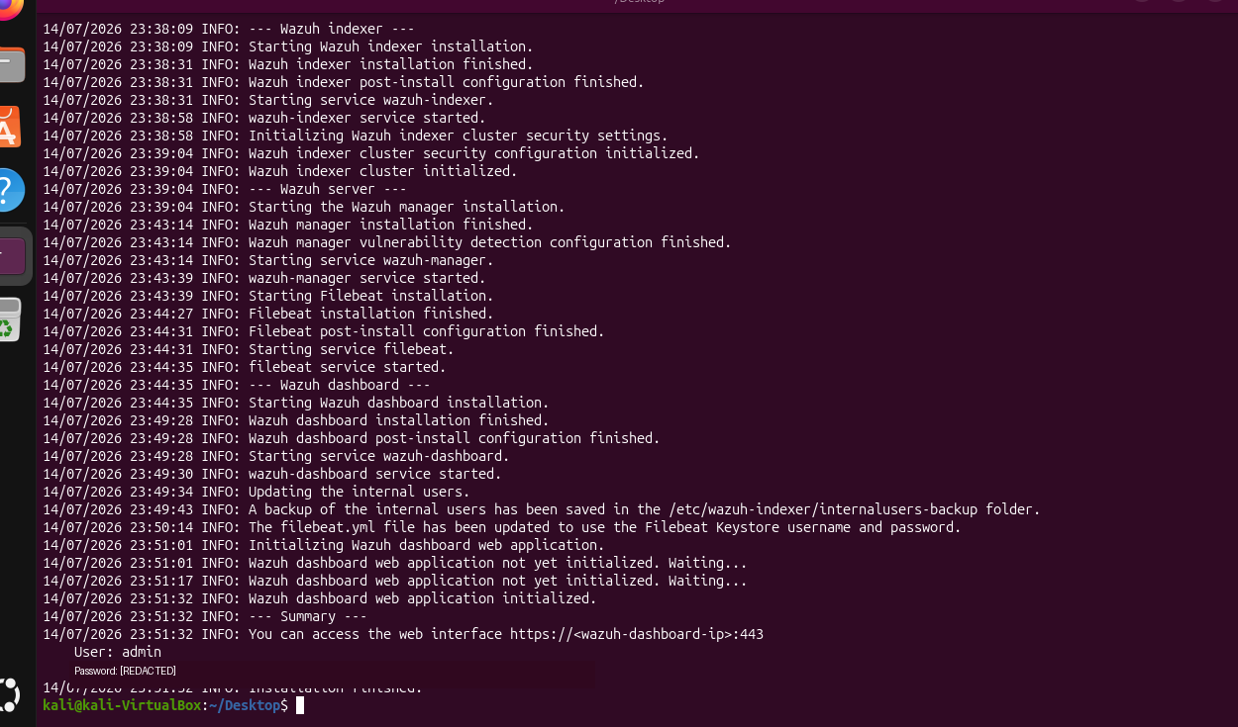
Figure 2. Wazuh installation completed successfully (password redacted).
Source: Author's controlled virtual lab.

5.6 Verify Wazuh Services
Ubuntu verification commands
sudo systemctl is-active wazuh-indexer wazuh-manager filebeat wazuh-dashboard
hostname -I

All four services returned active and the host-only IP remained 192.168.56.103.
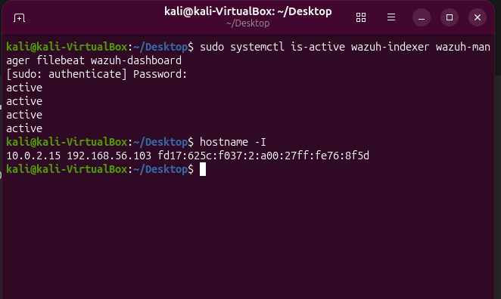
Figure 3. Ubuntu Wazuh services and host-only IP verification.
Source: Author's controlled virtual lab.

5.7 Open the Wazuh Dashboard
Address entered in the Windows browser
https://192.168.56.103

The dashboard was opened from the Windows VM or host browser using the Ubuntu host-only IP. The first connection showed a browser warning because the quickstart deployment uses a locally generated certificate. The warning was accepted for the private lab, and login was completed with username admin and the installer-generated password. The actual password is not reproduced in this report.

6. Windows Wazuh Agent Deployment

6.1 Download the Windows MSI
Administrator PowerShell
Invoke-WebRequest -Uri "https://packages.wazuh.com/4.x/windows/wazuh-agent-4.14.6-1.msi" `
-OutFile "$env:USERPROFILE\Downloads\wazuh-agent-4.14.6-1.msi"

6.2 Install and Enroll the Agent
The official Wazuh Windows procedure requires administrator privileges and accepts the WAZUH_MANAGER value during MSI installation [2]. The following command was used from an Administrator PowerShell window:
Agent installation command
cd "$env:USERPROFILE\Downloads"
msiexec.exe /i .\wazuh-agent-4.14.6-1.msi /qn /norestart `
/L*v .\wazuh-install.log `
WAZUH_MANAGER="192.168.56.103" `
WAZUH_REGISTRATION_SERVER="192.168.56.103" `
WAZUH_AGENT_NAME="Windows10-Agent"

6.3 Start and Verify the Agent Service
Administrator PowerShell
Start-Service wazuhsvc
Get-Service wazuhsvc

Verify manager connection
Get-Content "C:\Program Files (x86)\ossec-agent\ossec.log" -Tail 40

The service status changed to Running, and the agent log showed that the endpoint connected to 192.168.56.103 on TCP port 1514. Wazuh stores Windows agent files under C:\Program Files (x86)\ossec-agent by default [2].
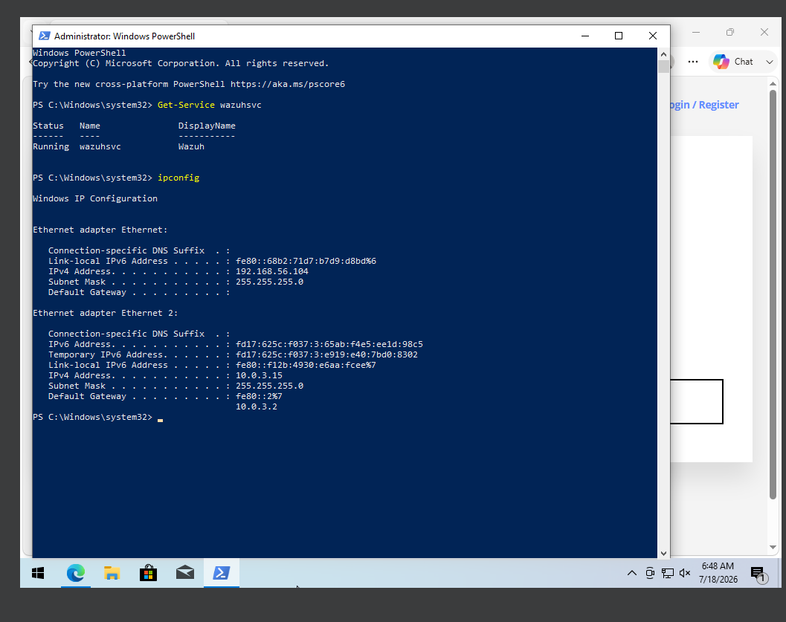
Figure 4. Windows Wazuh agent service and IP configuration.
Source: Author's controlled virtual lab.

6.4 Confirm the Endpoint in the Dashboard
In the Wazuh dashboard, the path Endpoints > Summary displayed Windows10-Agent with an Active status, IP address 192.168.56.104, and Wazuh version 4.14.6.
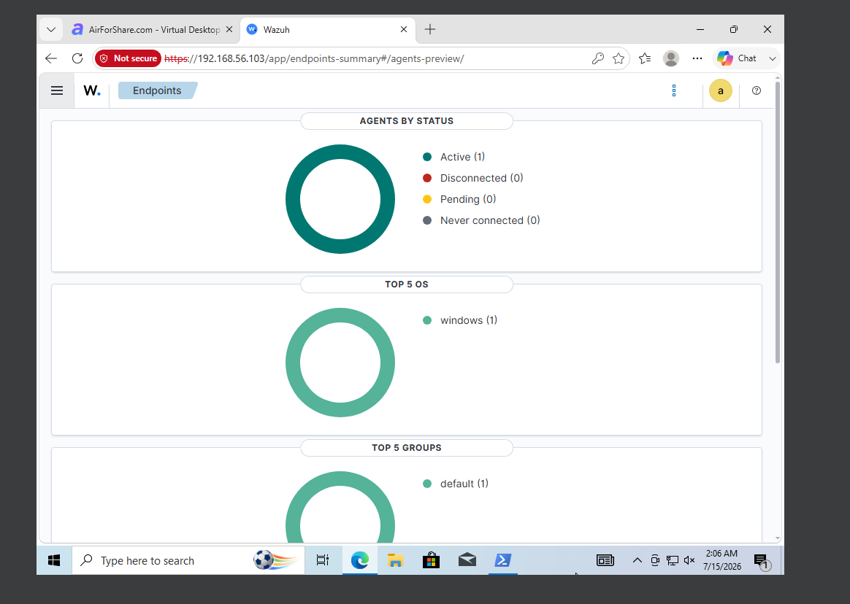
Figure 5. Active Windows endpoint visible in the Wazuh dashboard.
Source: Author's controlled virtual lab.

7. Preparing the Windows Victim for the SMB Test
Windows 10 Home cannot act as an incoming RDP host, so the project used SMB network authentication instead of RDP. The following commands enabled failed-logon auditing, started the Server service, allowed File and Printer Sharing in the private lab, and confirmed that TCP/445 was listening.
Administrator PowerShell on Windows
auditpol /set /subcategory:"Logon" /failure:enable
Set-Service LanmanServer -StartupType Automatic
Start-Service LanmanServer
Enable-NetFirewallRule -DisplayGroup "File and Printer Sharing"
Get-NetTCPConnection -LocalPort 445 -State Listen

Isolation requirement: Port 445 was exposed only inside the host-only laboratory network. The Windows VM must not be bridged to an untrusted physical network while this rule is enabled.

8. Baseline Attack: Detection Without Prevention

8.1 Verify the Victim Service from Kali
Kali command
nmap -Pn -p 445 192.168.56.104

The result showed 445/tcp open microsoft-ds, proving that the SMB service was reachable before the attack.
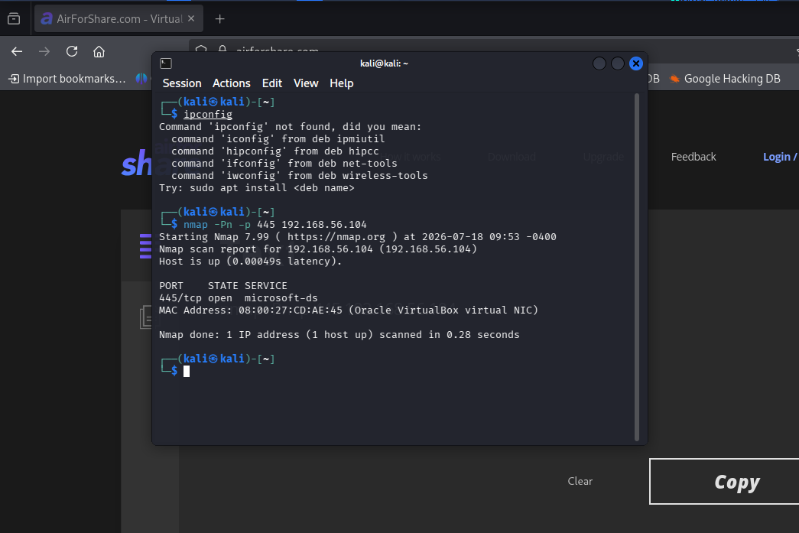
Figure 6. Kali Linux confirms TCP/445 is open before the attack.
Source: Author's controlled virtual lab.

8.2 Execute the Controlled Authentication Attack
The Samba smbclient utility can contact an SMB/CIFS server, and the -U option accepts a username while prompting for a password when no password is placed on the command line [8]. The following command was run five times, each time entering an intentionally incorrect password such as WrongPass123:
Kali attack command
smbclient -L //192.168.56.104 -U badguy

Expected baseline response:
session setup failed: NT_STATUS_LOGON_FAILURE

This response is important: it proves that the packets reached the SMB authentication service and were rejected only after an authentication attempt occurred.
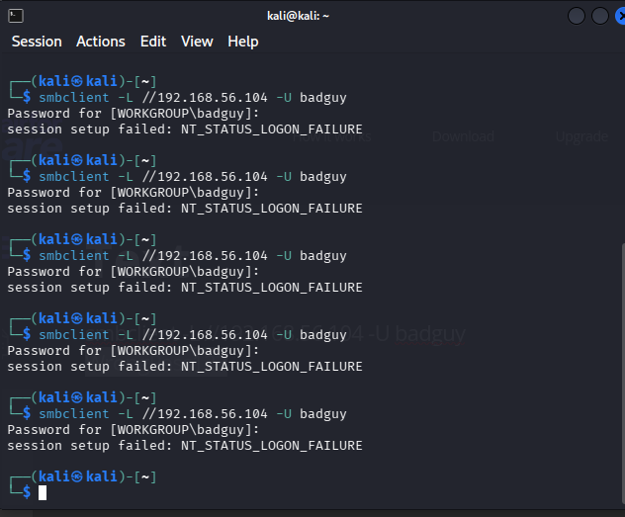
Figure 7. Five controlled SMB authentication failures generated from Kali.
Source: Author's controlled virtual lab.

8.3 Verify the Windows Security Event
Administrator PowerShell on Windows
Get-WinEvent -FilterHashtable @{LogName="Security";Id=4625;StartTime=(Get-Date).AddMinutes(-15)} | `
Select-Object -First 10 TimeCreated,Id,Message | Format-List

Microsoft documents Event ID 4625 as a failed logon event generated on the computer where the attempt was made. The event can contain the attempted account name and source network address [6].

8.4 Verify Detection in Wazuh
Dashboard path: Threat Hunting > Events. The time range was set to Last 15 minutes. Useful filters were:
Wazuh dashboard search filters
data.win.system.eventID:4625
data.win.eventdata.targetUserName:badguy
rule.id:60122

The Wazuh dashboard displayed five hits for Windows10-Agent. Each event was described as a logon failure for an unknown user or bad password and was mapped to rule ID 60122. Wazuh documentation explains that brute-force detection is based on correlating authentication failure events [5].
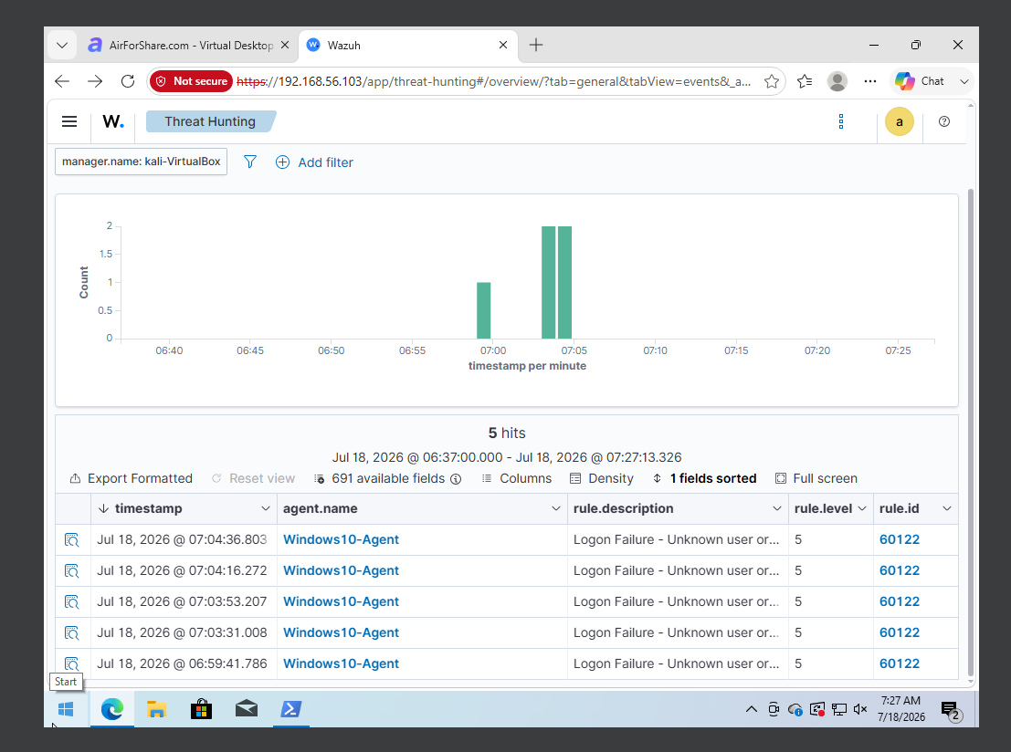
Figure 8. Wazuh detects five events under rule 60122.
Source: Author's controlled virtual lab.

8.5 Detection Gap Identified
Observation | Baseline result
Attack traffic reached the victim | Yes
Windows produced security events | Yes - Event ID 4625
Wazuh displayed alerts | Yes - Rule 60122
Kali source IP automatically blocked | No
TCP/445 remained reachable | Yes

This was the required detection gap: the SIEM reported the activity but allowed additional attempts from the same source.

9. Enabling Wazuh Active Response through the Dashboard
Wazuh Active Response can execute a command when an alert matches a rule ID, level, or group. The location value local means that the response runs on the monitored endpoint that generated the alert, and timeout defines how long the action remains in effect [3]. Wazuh includes netsh.exe as a default Windows response that blocks an IP address using Windows netsh [4].

9.1 Open the Manager Configuration Editor
- Open the Wazuh dashboard at https://192.168.56.103.
- Open the main menu.
- Navigate to Server management > Settings > Configuration.
- Click Edit configuration.

9.2 Add the Active Response Block
At the end of the manager ossec.conf file, immediately before the final </ossec_config> closing tag, insert:
XML added through the Wazuh dashboard
<active-response>
<disabled>no</disabled>
<command>netsh</command>
<location>local</location>
<rules_id>60122</rules_id>
<timeout>300</timeout>
</active-response>

Tag | Meaning
disabled = no | Enables this Active Response policy.
command = netsh | Uses the built-in Windows netsh response.
location = local | Runs the response on the Windows agent that generated the alert.
rules_id = 60122 | Triggers when the implemented failed-logon rule fires.
timeout = 300 | Keeps the source IP blocked for 300 seconds, then reverts the block.

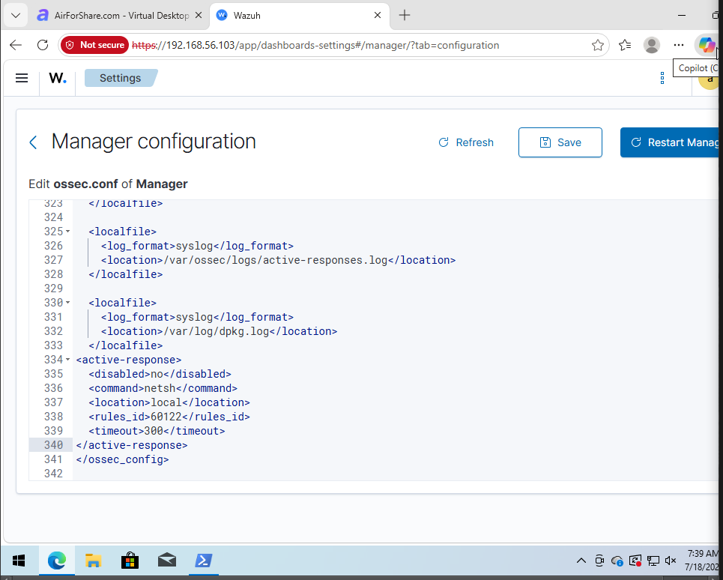
Figure 9. Active Response XML added through the Wazuh dashboard.
Source: Author's controlled virtual lab.

9.3 Save and Restart from the Dashboard
- Click Save.
- If validation succeeds, click Restart Manager.
- Confirm the restart.
- Wait for the API health check to recover and refresh the dashboard.
Important: The configuration method used in this project was the Wazuh dashboard editor. No Ubuntu text editor was required for the Active Response change.

10. Re-running the Attack and Validating Prevention

10.1 Repeat the Same Command
Kali command - identical to the baseline
smbclient -L //192.168.56.104 -U badguy

The first one or two attempts can still reach the victim because Wazuh must first receive and analyze the event before the response is executed. After the rule triggered, the next attempt returned:
do_connect: Connection to 192.168.56.104 failed (Error NT_STATUS_IO_TIMEOUT)

10.2 Confirm the Port is Blocked
Kali verification command
nmap -Pn -p 445 192.168.56.104

The result changed from open to filtered:
445/tcp filtered microsoft-ds

This change means the Kali source could no longer establish a connection to the Windows SMB service during the Active Response timeout.
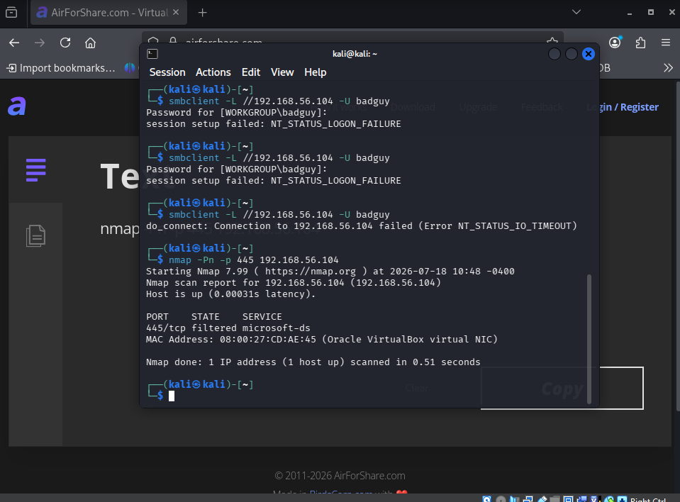
Figure 10. Same attack times out and TCP/445 becomes filtered.
Source: Author's controlled virtual lab.

10.3 Dashboard Evidence
In Threat Hunting > Events, set the time range to Last 30 minutes and search for the detection and response events:
Suggested dashboard filter
rule.id:(60122 OR 657)

Rule 60122 shows the failed authentication that triggered the response. Depending on log indexing and the active-response event mapping, rule 657 can be used to locate the Active Response execution event. The endpoint-side response log can also be checked when required:
Optional Windows verification
Get-Content "C:\Program Files (x86)\ossec-agent\active-response\active-responses.log" -Tail 30

The strongest observed prevention evidence in this lab was the combination of NT_STATUS_IO_TIMEOUT and the Nmap result 445/tcp filtered immediately after rule 60122 fired.
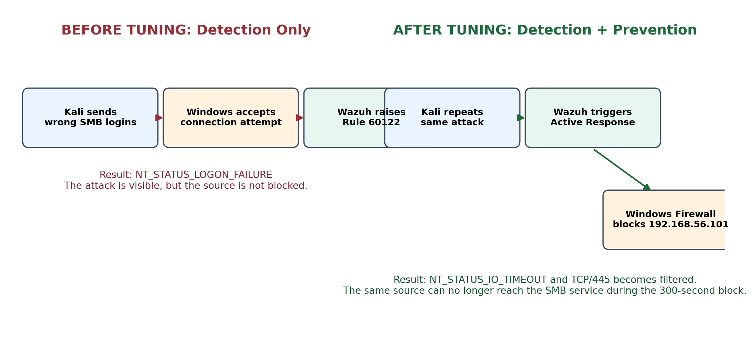
Figure 11. Before-and-after detection/prevention process.
Source: Created for this report from the observed experimental results.

11. Results and Discussion

11.1 Before-and-After Comparison
Measure | Before Active Response | After Active Response
Attack command | smbclient -L //192.168.56.104 -U badguy | Same command
SMB port state | open | filtered
Client result | NT_STATUS_LOGON_FAILURE | NT_STATUS_IO_TIMEOUT
Windows log | Event ID 4625 | Initial trigger event, then traffic blocked before later authentication
Wazuh action | Alert only - rule 60122 | Alert plus netsh Active Response
Attacker source blocked | No | Yes, for 300 seconds

11.2 Interpretation
The test demonstrates the distinction between visibility and response. In the baseline, the monitored service accepted the network connection and rejected the credentials, producing evidence for Wazuh. After tuning, Wazuh still needed an initial event to determine the malicious source, but it then instructed the Windows agent to create a temporary block. The same source could no longer reach port 445, so subsequent login attempts did not proceed to the SMB authentication stage.

11.3 Achievement of Project Objectives
Objective | Status | Evidence
Build isolated attacker, victim and SIEM VMs | Completed | Three host-only IPs and active services
Simulate an attack | Completed | Five failed SMB logons from Kali
Identify SIEM detection point | Completed | Wazuh rule 60122 / Windows Event 4625
Document the gap | Completed | Port remained open and repeated attempts continued
Tune the configuration | Completed | Active Response XML added via dashboard
Re-run the same attack | Completed | Identical smbclient command
Verify improvement | Completed | Timeout and filtered TCP/445

12. Troubleshooting and Lessons Learned

12.1 Unsupported Ubuntu Version
The already-installed Ubuntu VM reported Ubuntu 26.04. The official Wazuh quickstart lists Ubuntu versions through 24.04 [1]. Because the project deadline did not allow reinstallation, the lab used the installer override option. For a clean repeat or production deployment, Ubuntu 24.04 LTS should be used.

12.2 Limited Host Resources
The host had 16 GB RAM and a four-core Intel processor. Running Ubuntu, Windows and Kali simultaneously created pressure on the host. The Ubuntu VM was configured with 3 vCPUs and about 6 GB RAM. During demonstrations, the safest startup order was Ubuntu first, Windows second, and Kali last.

12.3 Host Disk Full During Installation
The Wazuh installation initially stopped when the Windows host drive containing the Ubuntu VDI became full. The Ubuntu VM was safely moved to the D: drive using VBoxManage. The command used was:
Windows Command Prompt
"C:\Program Files\Oracle\VirtualBox\VBoxManage.exe" movevm "ubuntu" `
--folder "D:\VirtualBox VMs" --type basic

Verification commands
"C:\Program Files\Oracle\VirtualBox\VBoxManage.exe" showvminfo "ubuntu"
"C:\Program Files\Oracle\VirtualBox\VBoxManage.exe" list hdds

After the move, the registered configuration and virtual disk locations were both on D:\VirtualBox VMs\ubuntu.

12.4 Interrupted Wazuh Installation
A host restart interrupted the installation after some components had been written. The installer was re-run with overwrite enabled, which completed the indexer, manager, Filebeat and dashboard installation.

12.5 Copy and Paste Problems
VirtualBox shared clipboard did not work initially. Short commands were typed manually, and Windows PowerShell/SSH was considered for easier command entry. For terminal paste on Linux, Ctrl+Shift+V should be used instead of Ctrl+V.

12.6 RDP Was Not Suitable
The Windows victim was Windows 10 Home, which does not provide the normal incoming Remote Desktop host capability. SMB authentication on TCP/445 was therefore selected as a shorter, repeatable alternative that still produced Windows failed-logon telemetry.

13. Security, Ethics and Limitations

13.1 Ethical Controls
- Only project-owned virtual machines were targeted.
- The host-only network prevented attack traffic from being sent to public systems.
- A non-existent username and intentionally wrong passwords were used.
- No credential theft, exploitation, malware execution, or privilege escalation was performed.
- Passwords generated by the Wazuh installer were redacted from evidence.

13.2 Limitations
- The experiment used one attacker, one victim, and one Wazuh server.
- The Active Response policy was tied directly to rule 60122 for demonstration clarity. Production environments should consider thresholds, allowlists, false-positive handling, and change control.
- The block duration was temporary (300 seconds).
- Ubuntu 26.04 and reduced hardware were lab constraints rather than recommended deployment choices.
- The baseline represented repeated failed authentication rather than a successful account compromise.

14. Conclusion and Future Work
The final experiment met the project proposal. A three-VM lab was built, Wazuh central components were installed on Ubuntu, and a Wazuh agent was enrolled on Windows. Kali Linux generated repeated SMB authentication failures that reached the victim and appeared in Wazuh as five rule 60122 events. This established the default detection-only state. Active Response was then configured through the Wazuh dashboard to run the built-in Windows netsh response for rule 60122. Repeating the identical command caused the connection to time out and changed TCP/445 from open to filtered. The project therefore produced a measurable before-and-after result: Wazuh moved from passive detection to automatic, temporary prevention.

14.1 Recommended Future Work
- Migrate the Wazuh server to Ubuntu 24.04 LTS with the recommended 4 vCPU and 8 GiB RAM.
- Create a custom correlation rule that triggers only after a defined number of failures within a time window.
- Add a safe allowlist for administrator and management IP addresses.
- Index and visualize Active Response execution events in a dedicated dashboard panel.
- Extend the laboratory with harmless malware-test telemetry, file integrity monitoring, and additional Windows endpoints.
- Measure detection time and response time automatically across repeated trials.

References
[1] Wazuh, “Quickstart,” Wazuh Documentation. https://documentation.wazuh.com/current/quickstart.html
[2] Wazuh, “Deploying Wazuh agents on Windows endpoints,” Wazuh Documentation. https://documentation.wazuh.com/current/installation-guide/wazuh-agent/wazuh-agent-package-windows.html
[3] Wazuh, “How to configure Active Response,” Wazuh Documentation. https://documentation.wazuh.com/current/user-manual/capabilities/active-response/how-to-configure.html
[4] Wazuh, “Default active response scripts,” Wazuh Documentation. https://documentation.wazuh.com/current/user-manual/capabilities/active-response/default-active-response-scripts.html
[5] Wazuh, “Detecting a brute-force attack - Proof of Concept guide,” Wazuh Documentation. https://documentation.wazuh.com/current/proof-of-concept-guide/detect-brute-force-attack.html
[6] Microsoft, “4625(F): An account failed to log on,” Microsoft Learn. https://learn.microsoft.com/en-us/previous-versions/windows/it-pro/windows-10/security/threat-protection/auditing/event-4625
[7] Oracle, “Virtual Networking / Host-Only Networking,” Oracle VM VirtualBox User Manual. https://docs.oracle.com/en/virtualization/virtualbox/7.2/user/networkingdetails.html
[8] Samba Team, “smbclient manual page,” Samba Documentation. https://www.samba.org/samba/docs/current/man-html/smbclient.1.html
[9] Project team, “SIEM & SOC: Attack Detection, Prevention and Logging - Project Proposal,” supplied project document, 2026. Local project document

Appendix A: Complete Command Checklist

A.1 Ubuntu Wazuh Server
sudo apt update
sudo apt install -y curl
curl -sO https://packages.wazuh.com/4.14/wazuh-install.sh
ls -lh wazuh-install.sh
sudo bash wazuh-install.sh --uninstall
sudo bash ~/wazuh-install.sh -a -o -i
sudo systemctl is-active wazuh-indexer wazuh-manager filebeat wazuh-dashboard
hostname -I

A.2 Windows Agent
Invoke-WebRequest -Uri "https://packages.wazuh.com/4.x/windows/wazuh-agent-4.14.6-1.msi" `
-OutFile "$env:USERPROFILE\Downloads\wazuh-agent-4.14.6-1.msi"
cd "$env:USERPROFILE\Downloads"
msiexec.exe /i .\wazuh-agent-4.14.6-1.msi /qn /norestart `
WAZUH_MANAGER="192.168.56.103" `
WAZUH_REGISTRATION_SERVER="192.168.56.103" `
WAZUH_AGENT_NAME="Windows10-Agent"
Start-Service wazuhsvc
Get-Service wazuhsvc
Get-Content "C:\Program Files (x86)\ossec-agent\ossec.log" -Tail 40

A.3 Windows SMB/Auditing Preparation
auditpol /set /subcategory:"Logon" /failure:enable
Set-Service LanmanServer -StartupType Automatic
Start-Service LanmanServer
Enable-NetFirewallRule -DisplayGroup "File and Printer Sharing"
Get-NetTCPConnection -LocalPort 445 -State Listen

A.4 Kali Attack and Verification
sudo apt update
sudo apt install -y nmap smbclient
ip -br address
nmap -Pn -p 445 192.168.56.104
smbclient -L //192.168.56.104 -U badguy
nmap -Pn -p 445 192.168.56.104

A.5 Dashboard Filters
data.win.system.eventID:4625
data.win.eventdata.targetUserName:badguy
rule.id:60122
rule.id:(60122 OR 657)

Appendix B: Live Demonstration Script
Step | Action | What to say to the audience
1 | Show architecture | “Kali is the attacker, Windows is the monitored victim, and Ubuntu hosts Wazuh.”
2 | Show Wazuh services active | “All central Wazuh services are running on 192.168.56.103.”
3 | Show Windows agent active | “The victim agent is connected and sending telemetry to Wazuh.”
4 | Run Nmap before tuning | “Port 445 is open, so the victim can receive SMB authentication requests.”
5 | Run five wrong logins | “The requests reach the victim; Windows rejects the credentials.”
6 | Show Wazuh five hits | “Wazuh detected five rule 60122 events but did not block the source.”
7 | Show dashboard XML | “We enabled Active Response through the Wazuh dashboard using netsh for 300 seconds.”
8 | Repeat same attack | “The command is unchanged, so the comparison is fair.”
9 | Show timeout and filtered port | “Wazuh triggered the endpoint firewall response; Kali can no longer reach SMB.”
10 | Show before/after summary | “The project demonstrates detection, gap analysis, tuning, re-testing, and prevention.”

Demonstration reset: Because timeout is 300 seconds, the temporary block should automatically expire after five minutes. For another live run, wait for the timeout or restart/verify the Windows firewall response state before beginning.

